PROJECT REVIEW:
SHRUTI JAIN
1.Introduction
The Hotel Driven Analysis project is developed using Microsoft Power BI to convert hotel booking data into meaningful business insights. The main goal of this project is to analyze revenue performance, compare City and Resort hotels.
By evaluating key metrics such as Total Revenue 2015, Total Revenue 2016, Total Revenue 2017and Average ADR and this dashboard helps identify growth trends and improve overall business performance in the hospitality industry.

2.Objectives of the Project
The objective of this project is to analyze hotel booking data to evaluate revenue performance. It aims to compare City and Resort hotels and generate insights that support effective business decision-making.
The specific objectives are:
- To analyze booking patterns and revenue trends.
- To compare the performance of City and Resort hotels by revenue
- To evaluate key metrics such as Total Revenue 2015, Total Revenue 2016, Total Revenue 2017and Average ADR
- To identify insights that improve profitability and planning.

3. Dataset Description
The dataset used for this project contains hotel booking information for both City and Resort hotels. It includes details related to customer bookings, stay duration, revenue, and booking behavior.
Key attributes in the dataset include Hotel Type, Arrival Year, Market Segment, Total Revenue, and Average Daily Rate (ADR), Date table, country. These variables help in analyzing Revenue based on Customer Type, Market segmen , country and Hotel

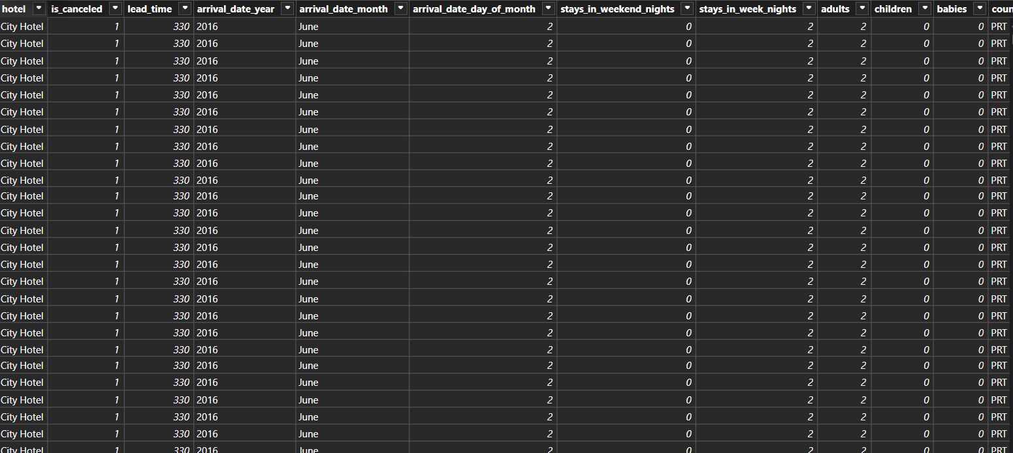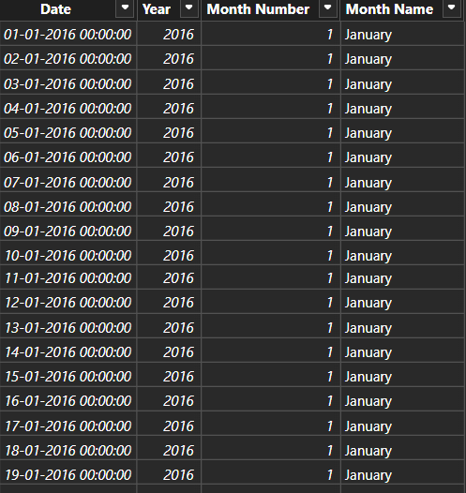

4.Methodology
The dashboard was created by following these step-by-step stages:
Step 1: Data Collection
Data Collection is the process of importing the hotel booking dataset into Power BI for analysis.
Step 2: Data Understanding
Data Understanding means reviewing the dataset to identify important fields such as Hotel Type, Revenue , Market Segment, Country , Average ADR
Step 3: Data Cleaning
Data Cleaning involves correcting data types, handling missing values, and removing unnecessary columns to ensure accuracy.
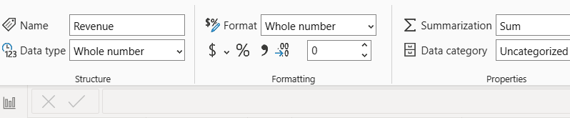

Step 4: Creating Calculations
Creating Calculations means developing DAX formulas to compute important metrics like Total Revenue, Total Revenue 2015, Total Revenue 2016 , Total Revenue 2017, and Average ADR
Step 5: Dashboard Development
Dashboard Development refers to designing KPI cards and charts to visually represent the data in a structured format.
Step 6: Analysis and Interpretation
This step involves examining the dashboard results to identify trends, compare performance, and generate business insights.

5. Dashboard Analysis
1. Hotel Revenue and Average ADR
This dashboard focuses on analyzing overall Revenue performance across each column and growth across different years.
1.1 Overview of Key Performance Indicators
The dashboard displays the following Cards:
- Total Revenue
Total Revenue 2015
- Total Revenue 2016
- Total Revenue 2017
- Average Daily Rate (ADR)
These metrics provide a quick summary of overall business performance.
1.2 Revenue Analysis and Average ADR
Revenue is analyzed based on:

Revenue based on each year
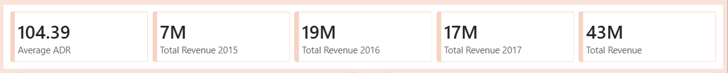

Revenue by Hotel Type
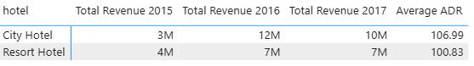

This helps identify peak-performing years and compare revenue contribution between City and Resort hotels and by each year
1.3 Revenue Analysis and Average ADR by Market Segment and Country
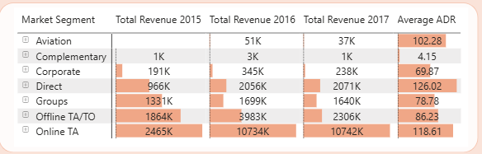

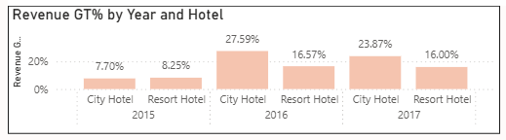
Revenue GT% (Growth Percentage) in hotel bookings represents the percentage change in total revenue compared to a previous, similar period (e.g., year-over-year or month-over-month)

1.4 Total Guests over year and Hotel
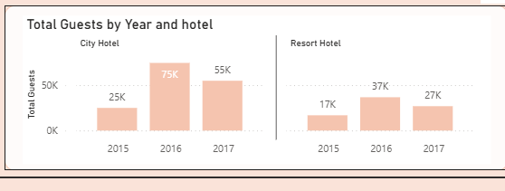

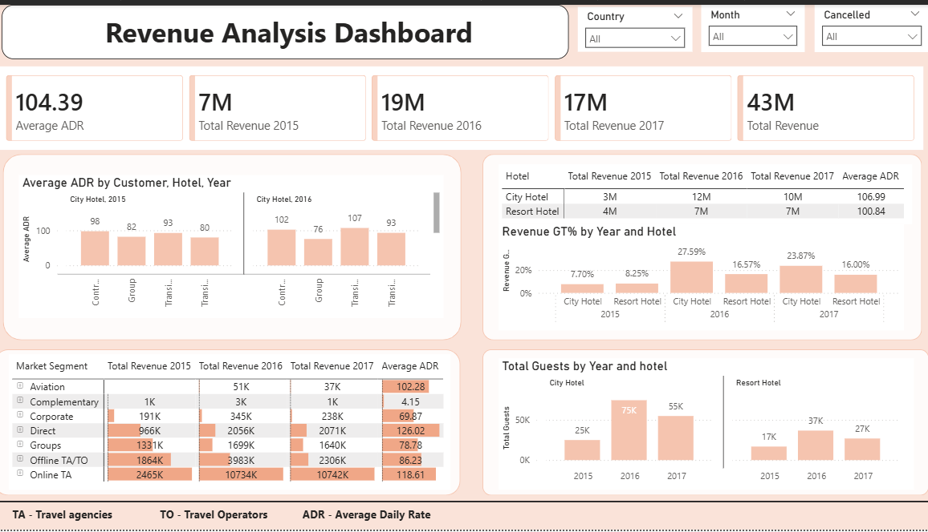
2.Hotel Revenue Analysis
This dashboard focuses Overall Analysis and also changes the dashboards design. Above is the final output

3.Conclusion
There we have combined all dashboard and insights of all the team members
Where it includes Customer Based, Booking Efficiency, Cancellation analysis, Hotel Overview, Revenue Analysis

4.Future Enhancements
- Revenue Optimization: Implement dynamic pricing strategies based on demand trends and booking patterns to maximize revenue.
- Segment-wise Revenue Analysis: Focus on high-revenue market segments such as Online TA and Corporate customers to improve profitability.

